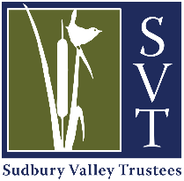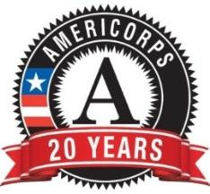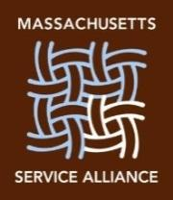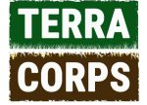
Request For Proposals:
TerraCorps Capacity Building Projects
Hosted by Sudbury Valley Trustees
TerraCorps (formerly MassLIFT) is a nonprofit based in Lowell, MA responsible for the management of a 48-member annual Massachusetts AmeriCorps program. Originally founded in 2010 within Mount Grace Land Conservation Trust, TerraCorps places AmeriCorps service members in land trusts and urban farming organizations across Massachusetts to meet critical community needs for land and watershed protection. The program is partially funded by the Corporation for National and Community Service grant and administered by the Massachusetts Service Alliance.
As a founding member of the TerraCorps program, Sudbury Valley Trustees is hosting two members for the coming year: a Community Engagement Coordinator and a Land Stewardship/Regional Collaboration Coordinator. The members are excited to aid SVT’s efforts in the SuAsCo watershed as well as to partner with other conservation and community entities in the area. These members each have their own unique set of skills and experiences that they are eager to apply to your committee’s or organization’s conservation projects.
RFP Objective
The mission of TerraCorps is to prepare and mobilize emerging leaders to help communities gain access to and conserve land for people and nature. TerraCorps’ vision is to build public support for land conservation, increase regional conservation capacity, accelerate the pace of land conservation and improve land stewardship. With this RFP, we seek to coordinate collaborative projects with one or more local land trusts, town commissions or other conservation or community organizations through the service of the AmeriCorps Community Engagement Coordinator or the Land Stewardship Coordinator. These projects should provide an opportunity for collaborative conservation between your organization and SVT.

Member’s Background
Jonathan Haarstick is joining SVT as the Community Engagement Coordinator. Jonathan graduated from the University of Massachusetts Amherst in 2020 where he studied marketing and natural resource conservation. In his role as Community Engagement Coordinator, Jonathan will focus on building connections between the environment and people that increase public support for land access, revitalization, and conservation initiatives. Through engaging diverse peoples and collaborating with community partners, Jonathan hopes to strengthen the connections between communities and local conservation efforts. He is interested in engaging with volunteers, facilitating collaboration between organizations, and promoting conservation work. Jonathan’s engagement opportunities may include developing culturally inclusive systems, programming, partnerships, and events.
Matt Morris is serving another year at SVT as the Land Stewardship Coordinator. He is aiming to further build the capacity of SVT to meet land stewardship responsibilities and to collaborate with municipal boards, local land trusts, and other community groups. These programs may include developing stewardship volunteer programs, baseline documentation, locating and marking boundaries, CR monitoring, trail maintenance, habitat restoration, and invasive plant management. Matt graduated from the University of New Hampshire in 2019 where he studied wildlife conservation and geospatial analysis. He is interested in conserving at-risk species and biological communities, habitat management, and wildlife corridors. He also hopes to provide opportunities for communities to engage with wildlife and conservation.
Project Examples:
- Recruit, organize and train stewardship volunteers to monitor or complete trail projects
- Joint outreach and volunteer engagement in habitat restoration or forest management
- Plan and organize a collaborative citizen science outreach event, such as a bio-blitz
- Provide a tool-kit for habitat management guidelines and develop action plans
- Empower and encourage urban communities to seek stewardship opportunities
- Organize a youth summit to gather information about how best to reach and involve high-schoolers in conservation efforts.
- Develop a toolkit of best practices for how to efficiently reach new diverse audiences through social media, communications and events.
- Collaborate with the representatives in regional cities, towns and local environmentally-focused groups to raise awareness of the importance and benefits of preserving healthy land and engaging with nature.

Proposal Guidelines
The proposal should have clear goals and a timeline. Projects should focus on building capacity for community engagement and stewardship. A capacity building project expands the scale, reach, efficiency, or effectiveness of programs and/or organizations. The training of staff or volunteers is expected in order to ensure these activities achieve lasting positive outcomes for the beneficiary organization and populations.
A town commission or local land trust can apply singly or together with another organization(s) or board.
Each project will receive approximately 120 hours of support from the AmeriCorps Member over a period of nine months (approximately mid-October through end of July).
Selection Criteria & Timeline
Proposals will be selected based on the following criteria:
- Will the project help to fulfill the overall mission of the TerraCorps program?
- How will the project address conservation needs in the community?
- Will the project build the capacity of the partner organization?
- Is the project feasible?
- Does the project match the skills and interests of the TerraCorps member?

You can read more about the Americorps program and previous projects with SVT on our website. The TerraCorps members’ service ends July 30th. Preference will be given to projects that can be completed prior to that date. Members will select 3-6 proposals total for the 2020 – 2021 service year.
The RFP deadline for submission is 9/25/2020.
Selection of projects will be made by 10/9/2020.
Questions and submissions can be sent to lmattei@svtweb.org. Please include “TerraCorps RFP” in the subject line.

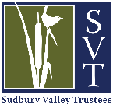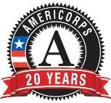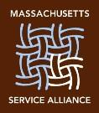
TerraCorps RFP Application Form
Hosted by Sudbury Valley Trustees
1. Identity
Organization Name:
Address:
City:
Website:
2. Contact Information
RFP Contact Name:
Title:
Email: Phone:
3 What is the mission of your organization? What do you do?
4. What are the capacity building goals of your project?
5. Which towns in the region will benefit from your project?
6. Please provide a clear and concise summary of your proposal.
7. What needs are being met by your proposal?
8. What impact will this project have on your organization and in your community?

Submit electronic applications to lmattei@svtweb.org by 9/25/2020. Please include “TerraCorps RFP” in the subject line.

